How to place an order AGENT DESK and Generate Closing Docs in DOC PREP.
- Login to the website at www.fidelitydesktop.com
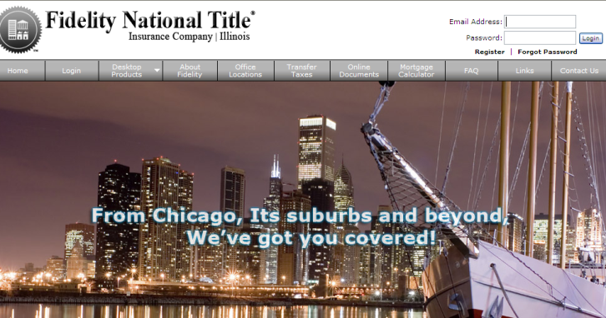
- Click PLACE AN ORDER
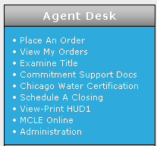

- Fill out the information for each step, BOLD fields are required
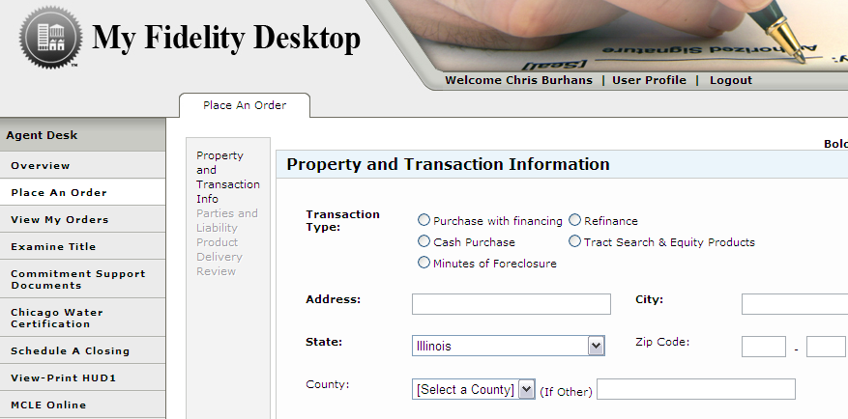
These are the order screens that will be displayed

- One the PRODUCT DELIVERY screen, you can add email addresses that will also get correspondence regarding that order. Simply click ADD EMAIL to add anyone not list, for anyone who is listed move their name to the right hand side to copy them for this order. The users email is copied by default

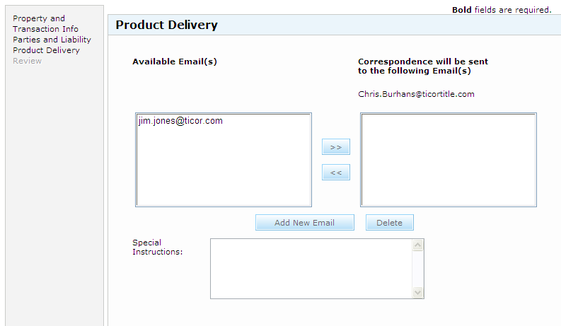

- You will receive a message saying “YOUR AGENT DESK ORDER has been submitted successfully” after submitting your order.

- The user will receive emails indicating the order number, and when the commitment application is uploaded. Upon receiving these emails, the order will be complete. To view the order click VIEW MY ORDERS after logging in.

- This will take you to a screen that has a summary of all your orders. Your order should look similar to the one below, with the status symbol indicating it is ready for the EXAM. You can start the exam by clicking the TITLE EXAM – PENDING button.

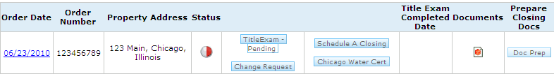

- This will take you into the title exam screen. The title exam is broken up into 3 main sections which are noted on the left hand side, with the icon indicating they are incomplete.

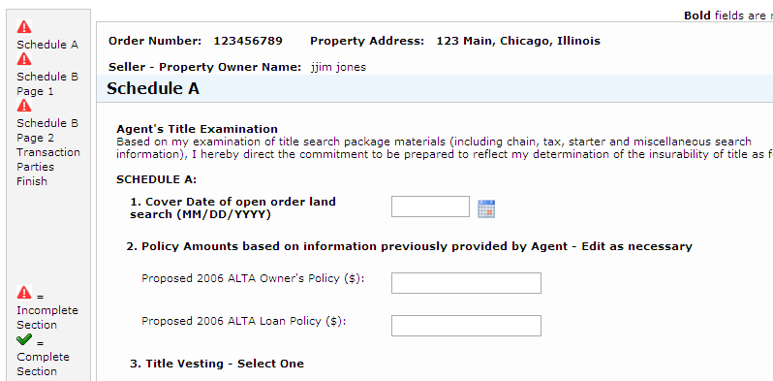

- Upon completing a section the icon will turn into a Green Check Mark. Using the SAVE and EXIT button at the bottom will allow for you to exit the exam and return later to complete.
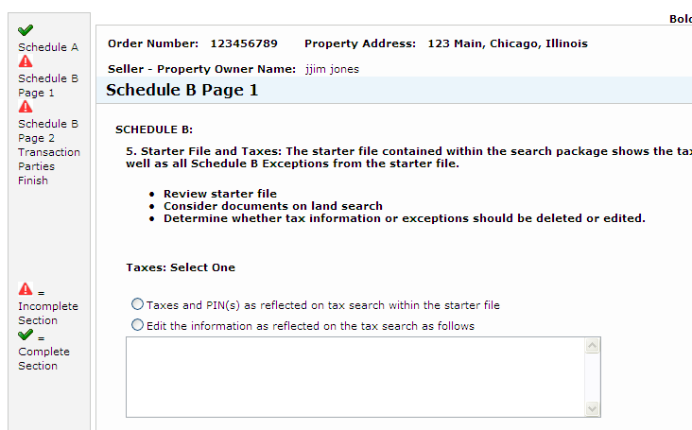

- Upon submitting the exam you will receive the message below.
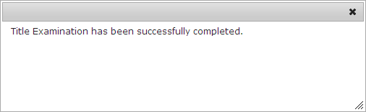

- After receiving the email that your commitment has been uploaded, you can return to the VIEW MY ORDERS screen for access to the commitment. To generate documents for you closing click the DOC Prep link and all your documents will feed into our Doc Prep Program.

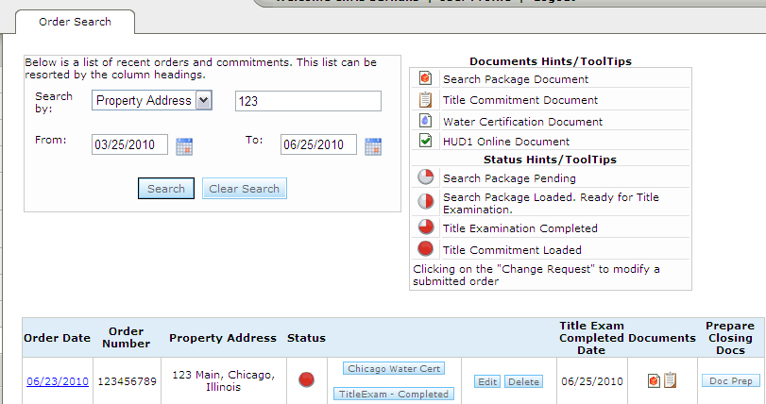

- Upon clicking DOC PREP you will be brought to our DOC PREP program and all the information from you order will feed into it, so no double entry is needed. The transaction name will be the property address by default, but this can be changed. Fill out all required information on the screens.

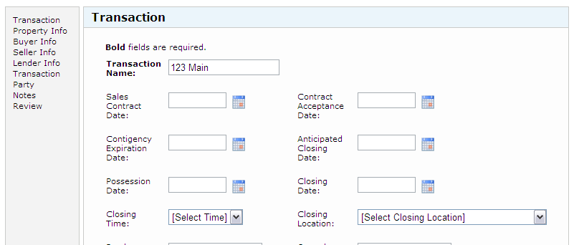

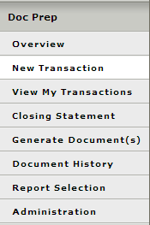
- Click the GENERATE DOCUMENTS on the left hand side to prepare you closing docs.

- Pick your order and push GENERATE DOCUMENTS once more.

- Simply select the documents on the LEFT and move them to the RIGHT and click NEXT.
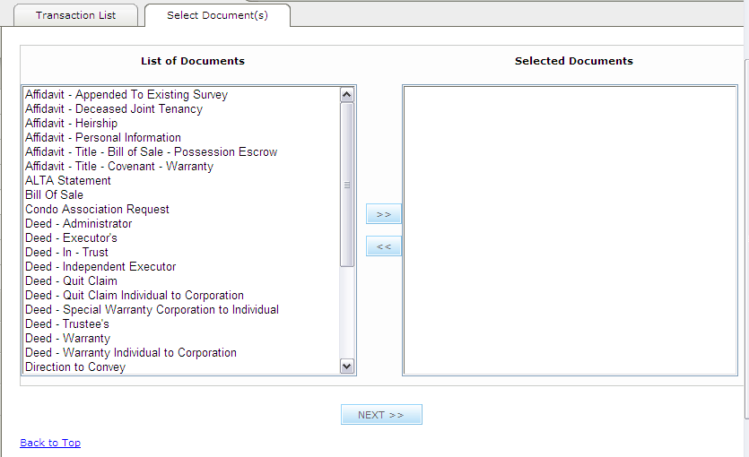
- This will provide a snapshot of the document for review, and then pushing GENERATE DOCUMENT at the bottom will produce a PDF version of your documents.
